Disability Inclusion Action Plan 2021-2025
Easy Read version

How to use this document
This information is written in an easy to read way. We use pictures to explain some ideas.

This document has been written by the City of Canada Bay Council. When you see the word “we”, it means the City of Canada Bay Council.

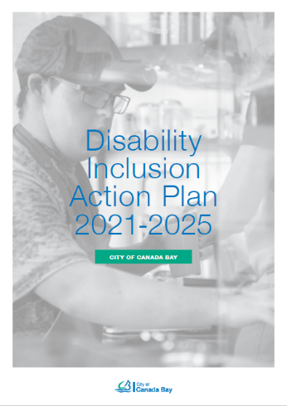
This Easy Read document is a summary of the Canada Bay Disability Inclusion Action Plan 2021-2025. We call this the “Plan”.

You can find the document on our website at
https://www.canadabay.nsw.gov.au/community/community-services/people-with-a-disability

You can ask for help to read this document.
A friend, family member or support person may be able to help you.

What is in this document?
How to use this document 1
What is in this document? 2
About the Plan 3
Why we need a plan? 4
How we made this plan 5
Our Plan 6
How we think and act 7
Making places for everyone 8
Making it easier to find a job 9
Improving how we do things 10

About the Plan

We want to:
- Make it easier for people to do the things they want to do
- Make sure everyone is included in the community
- Listen to what people think and learn from what they have experienced
- Treat everyone in a fair way and with respect

This Plan shows what we will do in the next 4 years.

Why we need a plan?

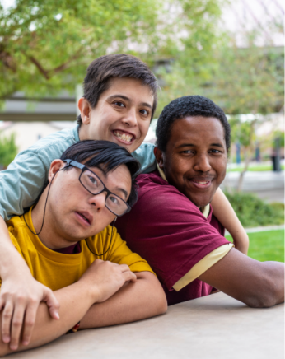
Lots of people live with disability.

Disability happens when it is hard for people to go about their daily lives.

This can happen because of:
- how we create our surroundings
- how we choose to communicate
- how people think
- how we treat others

The laws in Australia say we need to improve how we include people living with disability.

We are required to have a plan.

We want people living with disability to have the same opportunities and not be treated differently.

How we made this plan

We looked at what we have achieved and how we can do things better.

We asked people what we can do and how we can make living, working and visiting Canada Bay easier.

We talked to:
- People living with disability
- Carers
- Local groups
- Council staff
- People in the community

People told us their ideas by:
- Filling in a survey
- Going to a workshop or meeting
- Talking to us over the telephone

We put the ideas in the Plan.

Our Plan

The Plan looks at:
- What we want our community to be like
- What we will do
- How we make it happen

The Plan has to focus on 4 areas.
They are:
- How we think and act
- Making places that are for everyone
- Make it easier for people to find a job they like doing
- Improving how we do things to make it easier to use our services and to get information

How we think and act

We want:
- Our staff to learn more about how to be inclusive
- The community to learn more about people living with disability
- To celebrate and welcome everyone in our community

These are some of the things we will do:
- Teach staff and people in the community about what life is like for people with disability.
- Show the community and local businesses good examples of how to be inclusive.
- Celebrate and promote events important to our community.

Making places for everyone

We want to:
- Make it easier for people to move around
- Improve access to buildings, places, services and programs so that people can participate in activities
- Improve housing design

These are some of the things we will do:
- New places and buildings are designed for everyone
- Provide information about how to get around Council buildings and places
- Provide more street parking close to shops and services if needed
- Maintain safe footpaths, kerb ramps, road crossing, public spaces and upgrade bus stops
- Provide more accessible toilets
- Create inclusive spaces and programs for people living with disability

Making it easier to find a job

We want to:
- Make sure people living with disability have the same opportunities to work at Council
- Make businesses aware of the benefit of employing people living with disability.

These are some of the things we will do:
- Make sure the way we hire people is fair
- Make sure that if people need help to apply for a job or to do the job, it is provided.
- Make sure our documents are easy to read.

Improving how we do things

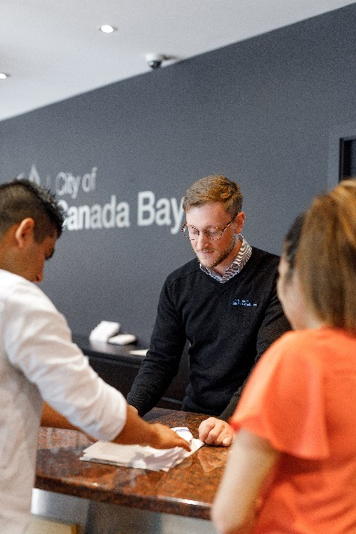
We want to:
- Make it easier for people to get information
- Make information easier to understand
- Be more inclusive in the way we do things

These are some of the things we will do:
- Make our information available in different formats
- Make sure our documents are easy to read
- When we ask for ideas, everyone can have their say
- Be responsible and do what we say we will do.

We want to thank everyone who helped with this Plan.

You can find more information at:
https://www.canadabay.nsw.gov.au/community/community-services/people-with-a-disability

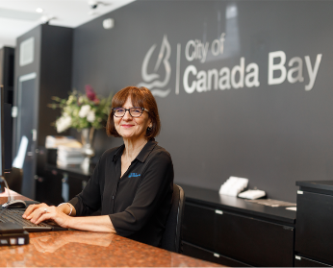
How you can contact us:
- Visit: Drummoyne Civic Centre
1a Marlborough Street, Drummoyne
- Call: (02) 9911 6555
- Email: council@canadabay.nsw.gov.au

